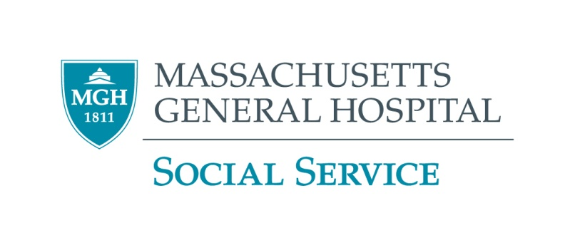

**Emergency Financial Assistance Funds**

**Important Note**

**Do you receive any needs-based benefits** (SSI, TAFDC, SNAP, housing subsidies, etc.)? If so, **please get advice from a legal service agency before applying** for any of these programs tolearn how they may affect your benefits.

Find your local legal service agency:

Massachusetts: <http://www.masslegalservices.org/FindLegalAid>

All other states: <http://ptla.org/legal-services-links>

**Modest Needs**

**Online only service that offers short-term financial assistance to low-income working individuals and families in temporary crisis. Offers two types of grants:**

* **Homecoming Heroes Grant: for veterans transitioning from overseas deployment to civilian life**
* **Self-Sufficiency Grant: for normally self-sufficient, low-income households**

**You must be a legal resident of the US or Canada to apply. For more on eligibility:** <https://www.modestneeds.org/for-applicants/faq.asp>**. For more information and to apply:** <https://www.modestneeds.org>**.**

**The Salvation Army**

The Salvation Army provides emergency financial assistance to help with rent and utilities. You do not have to be a citizen to apply. Search for the Salvation Army closest to you: <http://www.salvationarmyusa.org>.

**Jewish Family and Children’s Services**

Provides rent and utilities assistance to greater Boston area residents, regardless of religion or affiliation. 781-647-JFCS (5327)

**Catholic Charities**

Catholic Charities’ Basic Needs Fund provides rent and utility assistance. Search for the Catholic Charities closest to you: <https://catholiccharitiesusa.org>.

**The United Way**

The United Way First Call for Help is a good place to begin looking. They can give you information and a referral. Call them at 211. <https://unitedwaymassbay.org/>

**Your City or Town**

Contact your city or town to see if they offer emergency assistance. MA City/Town search: <http://www.sec.state.ma.us/cis/cistel/telidx.htm>

**Disease or Disability-Specific Funds**

There may be foundations that provide funds for people with your condition. Please consult your social worker for help locating any appropriate resources.

**Additional Agencies**

Also, try calling local religious organizations and local service groups such as the Elks, Jaycees, Kiwanis, Knights of Columbus, Lions and Rotary clubs

**Funds for Greater Boston Residents**

**The Lend a Hand Society**

Provides one-time emergency grants for low-income residents of **greater Boston** **regardless of immigration status.** **Social service advocates must apply on behalf of the person in need** by submitting a cover letter and the Agency Client Referral Form: <http://lah.dreamhosters.com/wp-content/uploads/2011/12/Agency-Client-Referral-Form.pdf>. **Please mail requests.** More information: <http://www.lend-a-hand-society.org>.

**The SWAN Society – for elder single, divorced, or widowed women**

Provides one-time, emergency grants to single, divorced or widowed women 65 and over who live within a **25-mile radius of Boston**. **Requires a professional to submit the application.** For more information, call 617-536-7951 or see <http://swansocietyboston.org>. The application is here: <http://swansocietyboston.org/forms/SWAN-Application.pdf>

**Rogerson Communities Elder Assistance Fund – for Boston elders**

Grants for **very low income Boston residents age 62 or older (or 55 or older and disabled)**. For **one-time** extraordinary expenses:

* Supplemental housing support due to an extraordinary circumstance such as fire, weather-related damage, moving, etc.
* Health-related equipment (air conditioner, dentures, prescriptions, etc.)

The fund **cannot** assist with any form of rental assistance or utility bills (phone, gas, or electric). However, it can help with emergency oil deliveries in some cases. **Requires a professional letter of support.** For more information and to apply, contact 617-327-1503 and ask for Resident Services Coordinator Giovana Russo.

**Funds for Other Massachusetts Residents**

**Cape Cod Times Needy Fund**

Provides one-time emergency assistance to Cape Cod residents for basic human needs (food, rent, mortgage payments, utility bills, medical costs and other basic expenses). Call 508-778-5661 or 800-422-1446.

**Personal Fundraising**

These websites allow people to ask family, friends, and even strangers for help. Most charge a fee of about 3-5% of the proceeds. **Please carefully read the fee schedules and other terms of service for these sites.**

Some popular sites (in no particular order):

* [YouCaring.com](http://www.youcaring.com/)*
* [GoFundMe.com](http://www.gofundme.com/)*
* [GoGetFunding.com](http://gogetfunding.com/)
* [Indiegogo.com](http://www.indiegogo.com/)
* [Kickstarter.com](https://www.kickstarter.com/)

* Do not charge percentage fees, but do charge pay processing fees from services like PayPal.